Analyzing the Impact of Eating Habits and Sedentary Lifestyle on Health Risk Patterns
Abdullah Nasim, Aditya Kumar Chaudhary, Shubhi Srivastav, Sharanjit Kaur
Department of Computer Science, Acharya Narendra Dev College,
University of Delhi, Delhi, India
InfoGraphic ABSTRACT
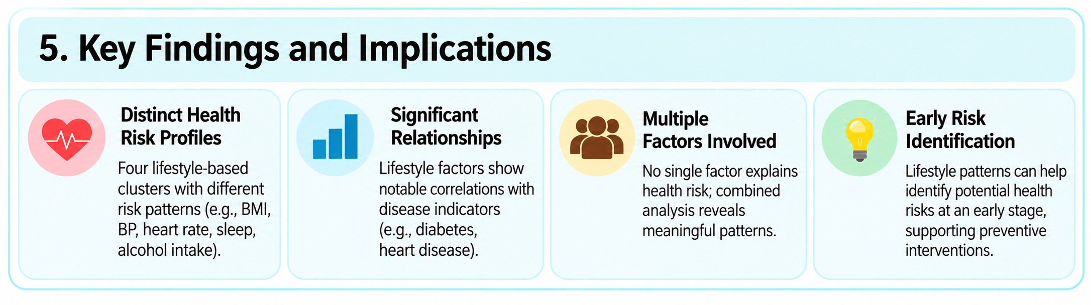
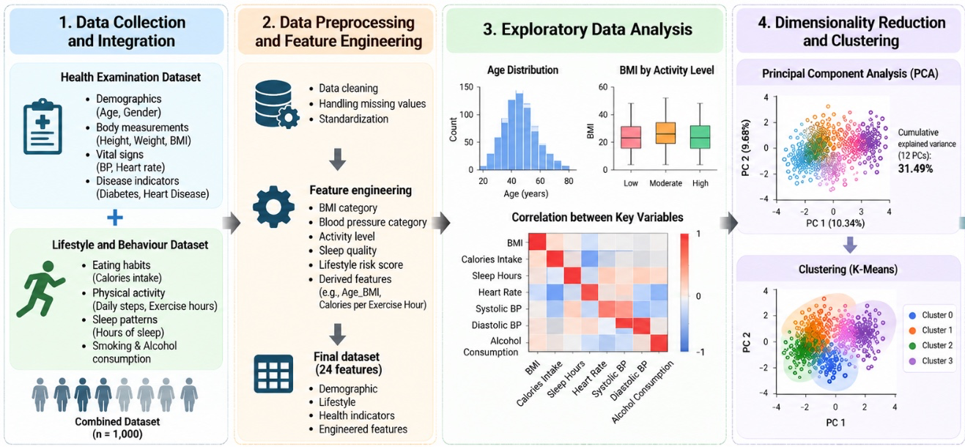
Today, sedentary lifestyle is a very common habit among young people and adults. Lifestyle and health are affected by many factors such as daily habits, physical activities, stress, sleep well-being, and other lifestyle habits. Therefore, this study examined the lifestyle habits using two datasets. The primary objective of the study to identify correlations between diseases and lifestyle habits, analyze patterns associated with disease occurrence in relation to lifestyle habits. Overall, we observed that lifestyle habits can contribute in identification of major health risks at an early stage. Also, these datasets suggest that one single factor cannot explain health risk.
Dataset 1: https://www.kaggle.com/datasets/ydalat/lifestyle-and-wellbeing-data
Dataset 2: https://www.kaggle.com/datasets/mahdimashayekhi/health-and-lifestyle-dataset

